Founders Day Activity

Bike Hike

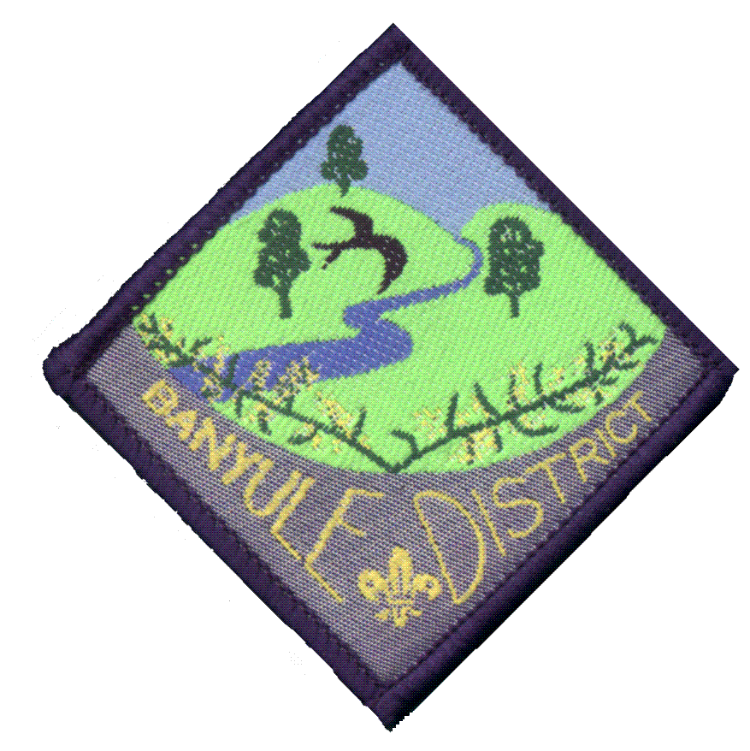
Sunday, February 21st 10.00AM
Please wear your cub uniform and correct footwear.
Banyule District Cubs Scouts1st Ivanhoe Sea Scouts
Meeting at Warringal Park and riding to Wilson Reserve.
Lunch will be served at Wilson Reserve. Pick up time 1.30 p.m.
MUST BRING: Bike, helmet, sunscreen, full drink bottle (+sunglasses?)
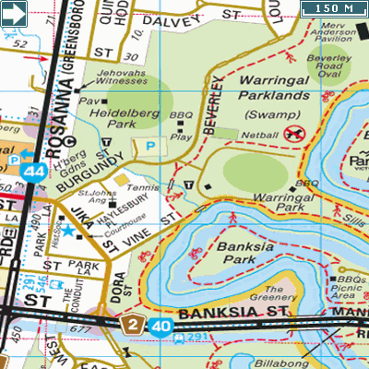
Starting point:
Warringal Park
Beverley Road off Burgundy St
Melway Ref 32 C4

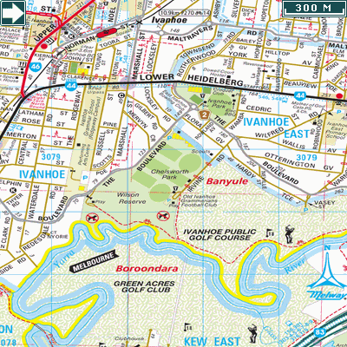

Finishing Point:
Wilsons Reserve, Ivanhoe
Melway Ref 31 F10/G10

Lunch Provided

Contact number for this event:
Wayne Renfrew (Akela) – 0411 121 495
……………………………………………………………….……………….………………………………………………………….…...

…………………………………………………………………………………………….….will be attending the Bike Hike and $ 5.00 per person is enclosed (Other family members attending must be supervised by parents also attending. All eating lunch need to pay $5).

Signed………………………………………………….…(Parent/Guardian) Date……….……….

